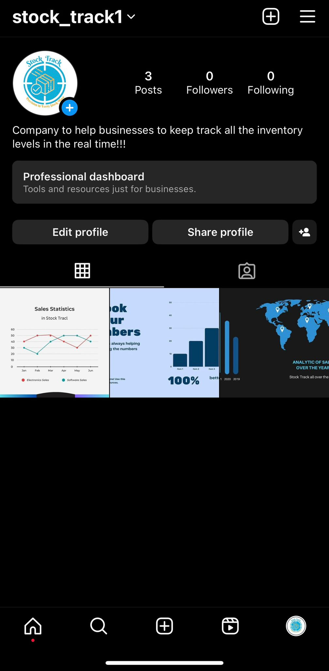

Social media is an important part of the marketing for whatever company, through social media customers can interact with, and always be updated. For the company to be successful having social media is extremely relevant and indispensable, so also apart from that the social media chosen for our company was Instagram because is easy to use and edit, for the customers know that is our account, the name for login was also (StockTrack) and most of the post would be analytics, checking costs, improvement, and giving advice about food and drink waste.